User-Centric Client Management with System Center 2012 Configuration Manager in Microsoft IT

Situation

Microsoft IT needed to evolve their Configuration Manager 2007-based environment that used homegrown application distribution services to meet the self-service needs of Microsoft personnel.

Solution

Microsoft IT deployed a new software installation portal based on System Center 2012 Configuration Manager that uses the new application model to distribute software more efficiently and that leverages the out-of-the-box Application Catalog and Software Center. Microsoft IT also engineered a backend load-balancing system to support the company's worldwide set of users.

Benefits

* **User-centric experience.** The new solution offers users an unprecedented level of control over how and when their software installations occur. Users can now self-select their primary systems, perform on-demand installations, plus schedule, request, and track activities.
* **Reduced TCO.** By replacing a homegrown solution with off-the-shelf technology, Microsoft IT expects to save an estimated $300,000 in updates and development costs over the next two years.
* **Reduced packaging costs and delivery times.** Microsoft IT has been able to remove the need for custom scripting on approximately 70% of their applications and has significantly improved turnaround times for those applications which require packaging. This equates to an additional estimated savings of $20,000 per year due to reduced packaging and testing costs.

Products and Technologies

* Microsoft System Center 2012 Configuration Manager
* Windows Server® 2008 R2
* Microsoft SQL Server® 2008 R2 SP1 CU4

Published: March 2012

Learn how Microsoft Information Technology used Microsoft® System Center 2012 Configuration Manager as the foundation of their new end-to-end application distribution and management solution. The new solution delivers a rich experience to users across multiple devices while maintaining the controls needed to protect corporate assets.

Situation

Today's corporations are struggling to balance their administrators' need for managing domain-joined systems while also accommodating employee requests to be more in control of their computers. Consider the variety of software that exists across all the different machines within an enterprise: how can IT improve on the user experience while maintaining control over corporate assets? Businesses must be able to promote user-centric features without reducing their ability to manage systems.

As the group responsible for maintaining the Microsoft corporate network and infrastructure, Microsoft Information Technology (Microsoft IT) is tasked with managing the company's internal application distribution portal, which is the primary means by which corporate users download system- and business-related applications to more than 280,000 computers.

Historically, Microsoft IT used two separate and unrelated homegrown systems to deliver application distribution services. In the first system, Microsoft IT provided a custom web interface to assist with end users' software needs; the second system utilized a custom packaging/wrapper tool to deploy the applications through Configuration Manager 2007. Turnaround time for a complex package could require 7 to 10 days, and it required the input of several IT personnel. Microsoft IT also maintained a separate Configuration Manager 2007 site to ensure that production setup was completely isolated from testing efforts.

The complex nature of these custom solutions, coupled with the necessity of allocating different servers for various services, translated into a high total cost of ownership. Microsoft IT recognized that System Center 2012 Configuration Manager offers a more intuitive, end-to-end application distribution and management experience that would provide a better user experience. In addition, by utilizing Role-Based Administration (RBA), Microsoft IT could consolidate application testing and production into a single environment. Finally, by basing the new solution on Configuration Manager, it would improve manageability, reduce packaging times, ease the administrative load, and ultimately reduce the total cost of ownership.

Solution

As the company’s first and best customer, Microsoft IT regularly adopts early releases of Microsoft technologies, tests them in a real-world environment, and provides critical feedback to improve products before they are generally available to the public. In order to improve its application management service, Microsoft IT worked closely with the product group to ensure that Configuration Manager can provide an end-to-end IT management experience, including an application distribution service that meets the needs of a real-world enterprise.

Why Configuration Manager?

System Center 2012 Configuration Manager has been designed from the ground up to empower end users to use the devices and applications they need to be productive. Configuration Manager ensures that the right types of applications are available on each device type while still enabling administrators to maintain corporate compliance and control. This latest version of Configuration Manager provides a unified infrastructure that delivers and manages rich user experiences across corporate and consumer devices.

In particular, Microsoft IT was interested in utilizing the following Configuration Manager features:

* New application model: System Center 2012 Configuration Manager introduces a new application model that Microsoft IT could use to fully incorporate their deployment standards without requiring custom wrappers. The richness of the application model further enabled Microsoft IT to switch to user-centric targeting while ensuring applications were delivered to the right users in the right way based on user identity and device type. Microsoft IT viewed the new application model's rich detection and lightweight policy-based architecture as a means to reduce the total turnaround time required to make an application ready for deployment. In addition, Microsoft IT could utilize Configuration Manager's supersedence and uninstall features to manifest complex deployment workflows for applications that require an orchestrated sequence, such as uninstall, reboot, and reinstall.
* User-centric features: System Center 2012 Configuration Manager brings a variety of user-centric initiatives that help Microsoft IT provide services with minimum impact to productivity, including:
  + Application Catalog: Microsoft IT wanted to replace their legacy website with this out-of-the-box, Web browser-based self-servicing portal that allows users to securely self-provision applications.
  + User Preferences: By offering Software Center as a new client-side interface to end users, Microsoft IT enables employees to control their own system management preferences, such as letting them define their business hours to minimize interruptions from mandatory software updates. Software Center also enables users to opt in or opt out of a variety of system settings, such as the Power Management feature.
  + **User Device Affinity:** This new feature in Configuration Manager allows users to identify a device as one of their primary systems. Microsoft IT can then leverage this information to limit restricted applications (such as those with high licensing costs) from being installed on systems that the user does not use regularly.
  + Built-in application provisioning technology: Configuration Manager enables Microsoft IT to reduce maintenance overhead and ease their total cost of ownership (TCO). For example, it enables Microsoft IT to replace some of the custom tools with its unified console and to utilize its built-in features to define deployment rules and conditions for successful application delivery.

Implementation

The following sections describe the various activities involved in Microsoft IT's implementation of their new System Center 2012 Configuration Manager-based application distribution solution.

Note: A separate Microsoft IT Showcase paper that discusses Microsoft IT's overall implementation strategy for System Center 2012 Configuration Manager is available at <http://technet.microsoft.com/en-us/library/hh913620.aspx>.

Defining New Application Models

Before the System Center 2012 Configuration Manager application model, Microsoft IT used a homegrown wrapper to build custom detections and conditions for each package to ensure that it would run only on machines that meet the software's system requirements—a very complex and time-consuming process.

In the new system, Microsoft IT uses Configuration Manager to quickly model the set of appropriate attributes and installation requirements (such as 64-bit OS, minimum of 4 GB RAM, and so on) for each application. The robustness and granularity of this new model ensures that a computer or device meets the requirements to install the application in a seamless manner.

In addition, Configuration Manager's supersedence and uninstall features enable Microsoft IT to streamline complex deployment workflows for those applications that require a full uninstall, reboot, and reinstall sequence.

Providing a New End User Experience

The new system's user-centric focus comes from two Configuration Manager features:

* Application Catalog: The first end-user-oriented feature is the Application Catalog, which is an interactive Web-based self-service application distribution portal that comes with System Center 2012 Configuration Manager. As shown in Figure 1, the Application Catalog uses the Configuration Manager application model to display filtered lists of available applications that are appropriate for the current user. By tying this feature to a transparent load-balancing infrastructure, Microsoft IT maximizes both server load balancing and network efficiency.

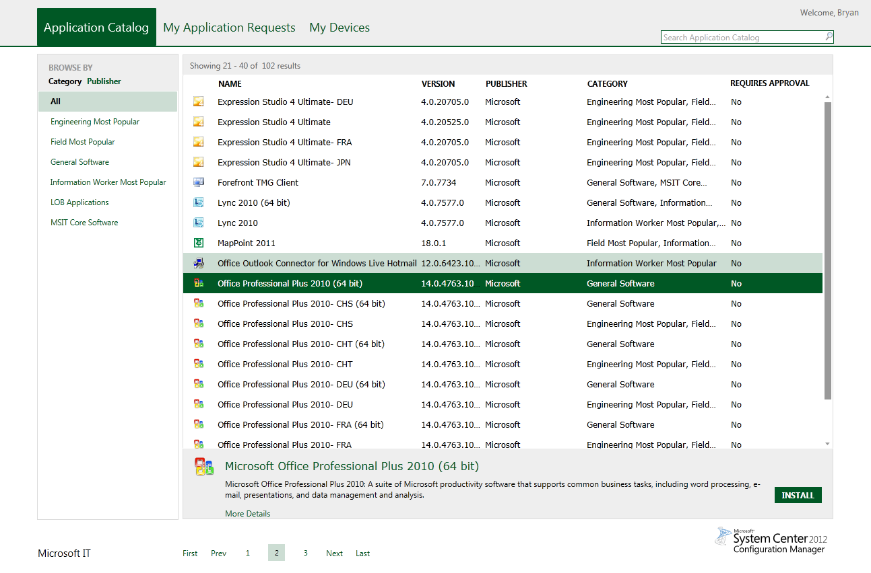Figure 1. Configuration Manager's Application Catalog portal.

* User Preferences: Software Center is a locally installed application that allows end users to configure various aspects of their application management. This tool enables Microsoft IT to engage the end user as a partner in their own application management decisions and provides a new management flexibility that was unavailable in the previous versions of System Center Configuration Manager.  
  As shown in Figure 2, end users can use Software Center to define work hours in order to better schedule installations during times that minimize productivity impacts. They can also choose to opt out of Microsoft IT's power management policies.

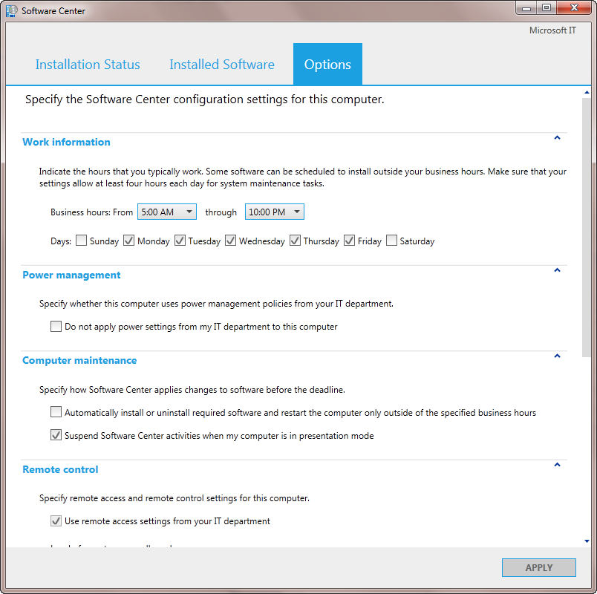

Figure 2. Software Center enables end users to configure many aspects of how Configuration Manager manages their system.

## Configuring Applications

Microsoft IT categorized the applications based on user groups (such as Engineering, IT, Marketing, and so on) in order to enable users to find the applications that they would most commonly access in the Application Catalog. Microsoft IT also inserted keywords into the catalog so that end users can easily find available applications.

Engineering a Load-Balancing Infrastructure to Application Catalog

Microsoft IT engineered a load-balancing infrastructure that could support their geographically distributed, multi-domain, multi-site Application Catalog for the company's worldwide set of users. Microsoft IT used the following technologies to engineer the load-balancing infrastructure for the application catalog website role:

* **Global traffic management*:** Uses the client system's subnet information to route the browser URL request to the appropriate geographical region. Each region can have one or more catalog sites.
* **Location traffic management*:** Determines which node within a region to send the user request. Microsoft IT utilized a "round-robin" method of load balancing that distributes user requests to different catalog sites.
* **IIS redirection:** Redirects the requests from the Microsoft Internet Information Services (IIS) root page to the appropriate application catalog's virtual directory.
* **Session persistence*:** Maintains a persistent session to the initially allocated catalog site, ensuring that each application catalog request that the user sends will connect directly to the same catalog server, which improves the user's browsing experience. Based on typical user activity, Microsoft IT decided to configure a 15-minute reset period for users to complete their catalog requests before the user would be passed back through the load balancers.

*\*Third-party technology*

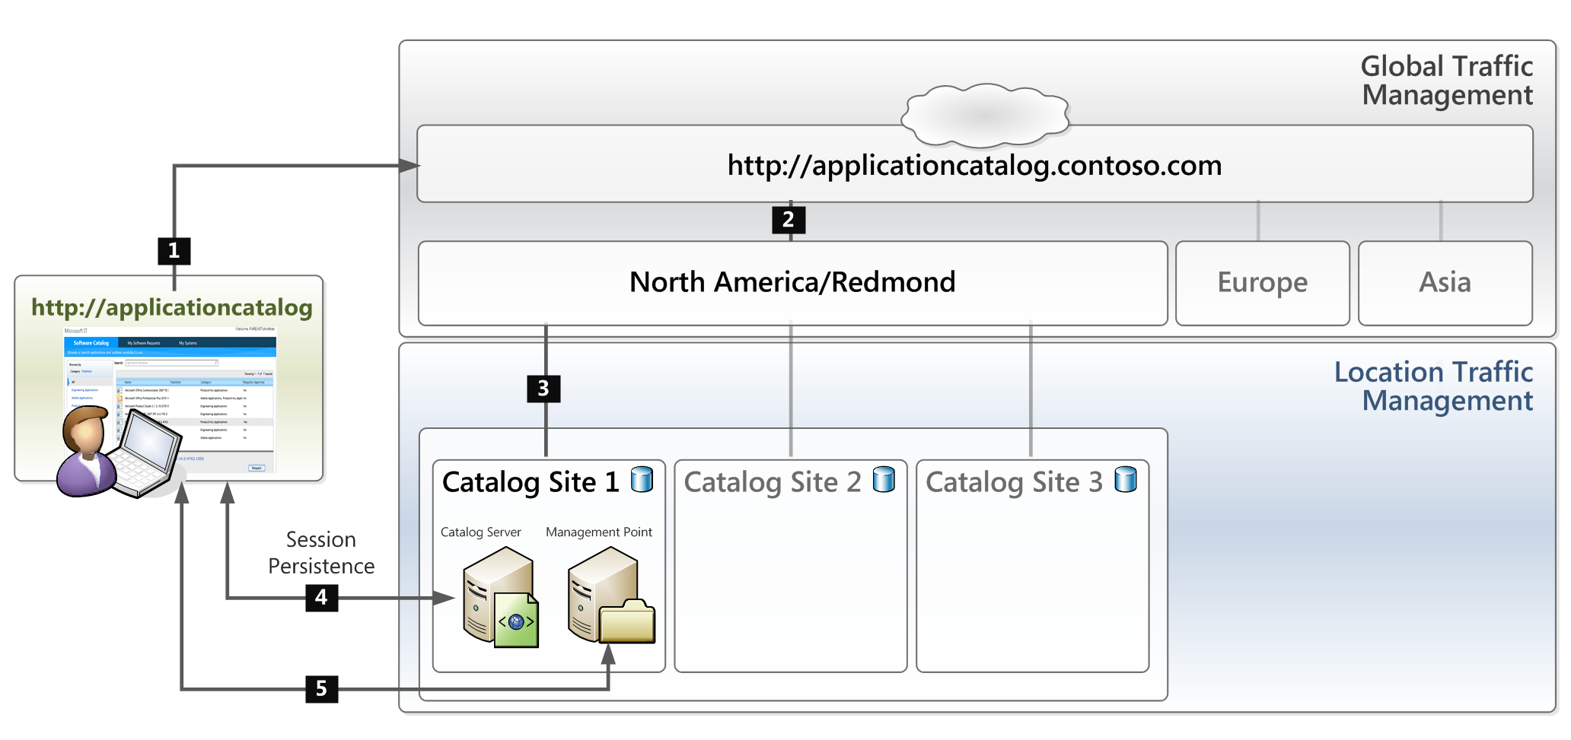Figure 3 displays a topology of the load-balancing infrastructure that Microsoft IT engineered for their new application distribution service.

Figure 3. The application distribution service's load-balancing infrastructure.

The numbers in Figure 3 indicate the following sequence of events that occurs when a user accesses the Application Catalog:

1. The user navigates to a single, "master" URL to access the catalog.
2. A third-party global traffic management technology routes the request to the appropriate geographic region based on the client machine's IP-subnet.
3. A third-party location traffic management technology selects which node within a geographical region to send the user request by operating "round-robin" style, passing each new user request to a different catalog site. The "master" URL is converted automatically to the appropriate regional catalog URL/virtual directory.
4. A third-party session persistence technology maintains a persistent connection to the allocated catalog site for 15 minutes. The user reviews the software available in the catalog site. When he or she selects an item and clicks Install, the request is sent to the management point to install the selected software.
5. The request is routed to the management point, and the content is deployed to the user's system from the distribution point.

Implementing Packaging and Testing Workflows with Role-Based Administration

Microsoft IT used System Center 2012 Configuration Manager's Role-Based Administration (RBA) control capabilities to refine their packaging and test team’s processes. Microsoft IT created a custom set of Configuration Manager *security roles* (permissions that give access to perform actions on certain types of objects) and *security scopes* (controls which object instances that the role administrator can see and interact with).

By establishing the appropriate combinations of roles and scopes, Microsoft IT established a sophisticated set of controls using RBA that merges their packaging and testing teams into a single Configuration Manager environment. Because their privileges are restricted to either application development or testing, these teams can integrate seamlessly into the software delivery life cycle without any potential impact to the production deployment.

Security Roles

Microsoft IT established the following roles:

* Packager Role: This custom role is derived from the default Application Administrator role that allows an administrator to create applications and packages, and to deploy them to test collections.
* Tester Role: This custom role has limited permissions, including Move Objects and Set Security scopes. Users with this role can change the scope on the objects to another scope to which they have access. For example, they can change the scope of the Application from Packager scope to Application Deployment scope.
* Deployment Admin Role: This custom role is based on the default Application Deployment Manager role, which allows administrators to deploy applications and packages, to create collections, and more.

Security Scopes

Microsoft IT created the following security scopes:

* Packager Scope: As with all scopes, users with this scope can only see the objects in that scope; any objects that they create will inherit this same scope. Packaging personnel are the primary recipients of this scope, which, in conjunction with the necessary roles (permissions), enable them to create objects.
* Application Deployment Scope: This scope is for users who have permission to deploy applications to the production collections, such as All Systems, All Users, and Users Groups.
* Tester Scope: Microsoft IT created a Tester scope for people who test the deployment packages. Testers also have access to the Packager scope and Deployment scope.

The following table summarizes Microsoft IT's role-scope combinations.

Table 1. Role-Based Administration Combinations

| Role Name | Permissions | On Objects | Scope | Collections |
| --- | --- | --- | --- | --- |
| Packager Role | Create, Modify, Retire, etc.  Deploy, Read | Application/ Package  Collection | Packager | Testing Machine |
| Tester Role | Set Security Scope, Move Objects | Application/ Package | Packager, Tester, Application Deployment | ------- |
| Deployment Admin Role | Read, Run Reports  Create , delete, deploy etc. | Application/ Package  Collection | Application Deployment | All Systems, All Users and Users Groups |

Note: This table reflects some of the role-scope combinations, but it should not be considered an exhaustive list of all required permissions.

Packaging and Testing Workflow

RBA enables Microsoft IT to define roles at a very granular level and helps ensure that the test and production activities are maintained separately, even while running on the same System Center 2012 Configuration Manager server.

The Packaging team creates the package/application in their scope. The Testing team then tests the package, removes the Packager Scope, and adds the Application Deployment Scope if it passes testing. With RBA, each role has a precise set of permissions required to complete the work without any overlap. For example, the Packager cannot edit the Application in production because he cannot see it as it is out of his scope. Similarly, the Deployment Admin cannot edit the package in production because he does not have access.

Deploying the Solution

In order to test and deploy their new Configuration Manager-based software distribution solution, Microsoft IT:

1. Initially created a virtual lab environment for test purposes. This environment included:
   1. An isolated domain with an independent domain controller.
   2. 14 virtual machine (VM)-based servers that formed the core test infrastructure.
   3. 10 VM clients to test the new client-side software functionality.
2. Confirmed that the solution functioned properly in the virtual environment before moving to a phased production rollout.
3. Created a communication channel to educate end users about the new system that included:
   1. Email messaging to notify users about the availability of the new service and a link to a new web page on an internal site where users could read more details.
   2. Information about how to engage with the company's Help Desk to address any potential questions or issues that might arise.
4. Implemented two new website roles, *Application Catalog web service point* and *Application Catalog website point.*
5. Deployed the new solution to approximately 10,000 machines in the initial phase of production rollout. The computers were all randomly chosen client systems within the company's Redmond domain.
6. Confirmed that the initial deployment to 10,000 systems was successful, and then:
   1. Expanded of the service to approximately 50,000 users within the company's Redmond domain; then
   2. Increased the scale of deploy to approximately 150,000 users in both the Redmond and North America domains; and finally
   3. Completed worldwide rollout, servicing an estimated 280,000 systems as of March 2012.
7. Commenced the process of phasing out the old homegrown solutions.

Results

The results from deploying the new Configuration Manager-based application distribution solution are as follows:

* Microsoft IT successfully deployed the new solution across the corporate network. As of March 2012, more than 280,000 systems in 8 domains across the globe are using it.
* With the full production rollout of the new solution, Microsoft IT has begun phasing out the old homegrown solutions.
* Microsoft IT has been able to remove the custom scripting requirement for approximately 70 percent of all deployments. In these deployments, Microsoft IT is able to use the application model to prepare an application for deployment in an average of 3 to 4 days, an activity that used to require 7 to 10 days using Configuration Manager 2007 with custom build wrappers.

Best Practices

When working with System Center 2012 Configuration Manager to implement the new end-to-end software deployment solution, Microsoft IT followed these best practices:

* Promote internal collaboration among all teams involved. Due to the number of different teams in your organization that may need to be involved—including business owners, Security, Compliance, Legal, and those who provide infrastructure—it is important to ensure that all stakeholders can provide input at an early stage and that they can work together to design a system that fulfills all key criteria.
* **Consider engineering a load-balancing infrastructure.** Enterprises may need to support large numbers of geographically distributed systems and workers. In this situation, you might want to plan to enhance Configuration Manager's Application Catalog feature with a load-balancing technology in order to maximize network efficiency and user productivity.
* Understand when to use the new application model versus classic software distribution. Not all deployments should be done with the application model. As an example, if you use batch files to periodically initiate maintenance tasks irrespective of the success state of the previous run, you should continue to use classic software distribution to deploy the batch file.
* Develop a detailed communication plan for end users. Plan how your IT team will communicate with end users and get them engaged with the deployment of Configuration Manager, the Application Catalog, and how they can use the Software Center to set their own preferences to be managed. Maximizing benefit from the technology requires that end users understand what is available to them and what application management choices they can set on their own.

# Benefits

By implementing an end-to-end application distribution solution based on System Center 2012 Configuration Manager, Microsoft IT derived a number of benefits:

* Empowered end users. Using the new user-centric solution, Microsoft IT can provide a flexible work environment to end users, enabling them to connect anywhere they have an Internet connection, with any device they choose. Configuration Manager automatically detects device configurations to determine the most appropriate services for each system. Microsoft IT uses the Application Catalog (the catalog website) and Software Center (the local utility) to offer users an unprecedented level of control over how and when their software installations occur. Furthermore, by incorporating the Configuration Manager User Device Affinity feature into the new solution, Microsoft IT allows users with more than one managed device to self-select their primary systems. The system can then allocate restricted software to be installed solely to frequently used devices.
* **Reduced TCO.** Configuration Manager was key to Microsoft IT's simplifying and consolidating their IT infrastructure. By replacing a homegrown system with off-the-shelf technology, Microsoft IT expects to reduce their total cost of ownership, saving an estimated $300,000 in updates and development costs over the next two years.
* **Streamlined packaging process.** Using the application model, Microsoft IT has been able to remove the need for custom scripting on approximately 70 percent of the applications and has seen improved turnaround times on those applications that still require packaging.
* Improved application management. The new application model of Configuration Manager provides Microsoft IT with a much more powerful method of managing end-to-end application life cycles. In addition, Microsoft IT is leveraging the Configuration Manager uninstall and supersedence features in order to facilitate good user experiences with complex application uninstall, re-install, and upgrade scenarios. Microsoft IT can even automatically enforce application compliancy through the application model by having the system regularly identify and enforce installation of required software on eligible machines.
* **Improved access control:** Configuration Manager's Role-Based Administration (RBA) has enabled Microsoft IT to integrate their packaging and test teams into the production console with minimal risk of unintended deployments. By so doing, RBA has enabled Microsoft IT to decommission their legacy testing hierarchy, providing additional operational and maintenance savings.
* Enhanced monitoring capabilities. Microsoft IT is using rich reports that offer insights into application installation failures and application compliance metrics.

Conclusion

Microsoft IT wanted to replace their old homegrown application distribution systems with a new end user-focused solution based on System Center 2012 Configuration Manager. By leveraging Configuration Manager's Application Catalog and Software Center features, Microsoft IT was able to give end users more control over their systems while still enabling administrators to maintain corporate compliance and control. Microsoft IT also saw a significant improvement in the turnaround time to package software: using Configuration Manager's application model has reduced the turnaround time for a highly complex package from 7 to 10 days down to 3 to 4 days.

In addition to the Application Catalog and Software Center, Microsoft IT engineered a load-balancing infrastructure to support their large number of users across the globe. As of March 2012, more than 280,000 systems in 8 domains around the world are using the new solution.

The new System Center 2012 Configuration Manager-based solution brings significant improvements to the management experience for administrators and end users alike. The Configuration Manager application model enables Microsoft IT to build robust application distribution models based on user identity, device type, and network; and the new Software Center allows employees to set a variety of preferences, including how and when mandatory software changes occur.

With the full production rollout of the new solution, Microsoft IT has begun phasing out the old homegrown solutions. Microsoft IT anticipates saving approximately $300,000 in custom tool development and update costs over the next two years, plus an operational savings of $20,000 per year for reduced packaging and testing costs.

For More Information

For more information about Microsoft products and services, call the Microsoft Sales Information Center at (800) 426-9400. In Canada, call the Microsoft Canada Order Centre at (800) 933-4750. Outside the 50 United States and Canada, please contact your local Microsoft subsidiary. To access information via the World Wide Web, go to:

<http://www.microsoft.com>/

<http://www.microsoft.com/technet/itshowcase/>

<http://www.microsoft.com/en-us/server-cloud/system-center/configuration-manager-2012.aspx>

© 2012 Microsoft Corporation. All rights reserved.

This document is for informational purposes only. MICROSOFT MAKES NO WARRANTIES, EXPRESS OR IMPLIED, IN THIS SUMMARY. Microsoft, SQL Server, and Windows Server are either registered trademarks or trademarks of Microsoft Corporation in the United States and/or other countries. All other trademarks are property of their respective owners.